Electronic System design -ALM-1

Electronic Components Investigation Report
Y.Harsha vardhan 2400040454

Each component includes a brief Explanation, Work Function, Importance & Application, Schematic Symbol description, and Internal Configuration overview.

Component Analysis Summary
Here is a comprehensive report covering 50 electronic components with concise descriptions, work functions, and applications in table format:

No. | Component | Explanation | Work Function | Importance & Application
1 | Resistor | Passive component that opposes current flow | Limits current and divides voltage according to Ohm's Law (V=IR) | Essential in all circuits for current control, voltage division, and biasing
2 | Capacitor | Stores electrical energy in electric field | Stores and releases charge; blocks DC and passes AC | Used in filtering, coupling, decoupling, timing circuits, and energy storage
3 | Inductor | Stores energy in magnetic field | Opposes changes in current flow; stores energy magnetically | Used in filters, transformers, chokes, and oscillator circuits
4 | Diode | Semiconductor allowing unidirectional current | Conducts current in forward bias, blocks in reverse bias | Rectification, signal clipping, voltage regulation, and protection
5 | Transistor (BJT) | Three-layer semiconductor device (NPN/PNP) | Amplifies signals or acts as electronic switch | Fundamental in amplifiers, switches, and digital logic circuits
6 | LED | Light emitting diode | Emits light when forward biased due to electron- hole recombination | Indicators, displays, lighting, and optical communication

7 | Integrated Circuit (IC) | Multiple components on single chip | Performs complex functions like amplification, logic operations | Found in all modern electronics - microprocessors, memory, controllers
8 | Transformer | Electromagnetic induction device | Steps up or down AC voltage through mutual induction | Power distribution, voltage conversion, and isolation
9 | Relay | Electromechanical switch | Uses electromagnet to control high power with low power signal | Switching heavy loads, isolation, and automation systems
10 | Switch | Manual or automatic circuit breaker | Opens or closes circuit to control current flow | Basic control element in all electrical devices
11 | Potentiometer | Three-terminal variable resistor | Adjusts resistance by moving wiper contact | Volume controls, sensor calibration, voltage adjustment
12 | Photodiode | Light-sensitive diode | Converts light energy into electrical current | Optical sensors, light meters, communication receivers
13 | Phototransistor | Light-sensitive transistor | Amplifies light-generated current | Light detection with amplification in automation and remote controls
14 | Zener Diode | Special diode for voltage regulation | Operates in reverse breakdown region maintaining constant voltage | Voltage reference and regulation circuits
15 | Schottky Diode | Metal-semiconductor junction diode | Fast switching with low forward voltage drop | High-frequency rectifiers and power supply circuits
16 | Varistor (MOV) | Voltage-dependent resistor | Resistance decreases with increasing voltage | Surge protection and voltage spike suppression
17 | Thermistor | Temperature-sensitive resistor (NTC/PTC) | Resistance varies significantly with temperature | Temperature sensing, measurement, and circuit protection
18 | Crystal Oscillator | Piezoelectric resonator | Generates precise frequency signals | Clock generation in microprocessors and communication systems
19 | Piezoelectric Crystal | Mechanical-electrical converter | Converts pressure/vibration to electrical signals | Sensors, buzzers, resonators, and frequency control

20 | Fuse | Protective overcurrent device | Melts and breaks circuit when current exceeds rating | Circuit protection from overcurrent and short circuits
21 | Voltage Regulator | Voltage stabilization IC | Maintains constant output voltage despite input variations | Power supplies requiring stable voltage output
22 | Resistor Network | Multiple resistors in single package | Provides multiple resistance values compactly | Space-saving in complex circuits like DACs and pull-up arrays
23 | Capacitor Network | Array of capacitors in one package | Multiple capacitance values in compact form | Decoupling, filtering, and timing circuit arrays
24 | DIP Switch | Dual in-line package switch array | Multiple switches for configuration settings | Hardware configuration and mode selection
25 | Heat Sink | Thermal management device | Dissipates heat through increased surface area | Prevents thermal damage to power components
26 | Buzzer | Acoustic signaling device | Converts electrical signal to audible sound | Alarms, alerts, and audio feedback systems
27 | Speaker | Electroacoustic transducer | Converts electrical audio signals to sound waves | Audio output in entertainment and communication devices
28 | Microphone | Acoustic-to-electric transducer | Converts sound waves into electrical signals | Audio input in recording and communication systems
29 | Antenna | RF signal radiator/receiver | Transmits/receives electromagnetic waves | Wireless communication, radio, and RF systems
30 | Battery | Electrochemical energy storage | Converts chemical energy to electrical energy | Portable power source for mobile devices
31 | Solar Cell | Photovoltaic device | Converts light energy directly into electricity | Renewable energy generation and portable power
32 | Breadboard | Solderless prototyping platform | Allows temporary circuit connections without soldering | Quick circuit prototyping and testing
33 | Connector | Electrical interface component | Provides mechanical and electrical connection | Interconnecting circuits, cables, and modules
34 | Jumper Wire | Flexible connecting wire | Makes temporary electrical connections | Breadboard prototyping and circuit testing

35 | LDR | Light Dependent Resistor | Resistance decreases with increasing light intensity | Automatic lighting, light sensing, and photometry
36 | Push Button | Momentary contact switch | Closes circuit only when pressed | User input and control interfaces
37 | Trimmer Capacitor | Adjustable small capacitor | Fine-tunes capacitance for circuit optimization | Frequency tuning and calibration circuits
38 | Trimmer Resistor | Adjustable precision resistor | Provides fine resistance adjustment | Circuit calibration and precision adjustments
39 | Oscilloscope Probe | Signal measurement tool | Connects circuits to oscilloscope with minimal loading | Signal measurement and circuit debugging
40 | PCB | Printed Circuit Board | Mechanically supports and electrically connects components | Foundation platform for electronic assemblies
41 | Logic Gates | Digital logic building blocks | Performs Boolean operations (AND, OR, NOT, etc.) | Fundamental elements of digital circuits and computing
42 | Signal Generator | Test equipment | Produces periodic electrical signals of various waveforms | Circuit testing, calibration, and development
43 | Power Supply | Power conversion unit | Converts and regulates electrical power | Provides appropriate voltage and current to circuits
44 | Operational Amplifier | High-gain differential amplifier IC | Amplifies voltage difference between inputs | Signal conditioning, filtering, and mathematical operations
45 | Programmable Logic Device | Configurable digital IC | Implements custom logic functions | Complex digital designs, prototyping, and FPGA applications
46 | RC Circuit | Resistor-Capacitor combination | Filters or generates time delays | Signal filtering, timing, and integration/differentiation
47 | LC Circuit | Inductor-Capacitor combination | Resonates at specific frequency | Oscillators, filters, and RF tuning circuits
48 | Voltage Divider | Series resistor network | Produces fractional voltage from source | Voltage scaling, sensor interfacing, biasing
49 | SCR | Silicon Controlled Rectifier (Thyristor) | Switches high power loads with gate control | Power control, motor drives, and rectification

50 | 7-Segment Display | Numeric/alphanumeric display | Shows digits using seven LED/LCD segments | Digital displays in clocks, meters, calculators

Schematic Symbols Reference
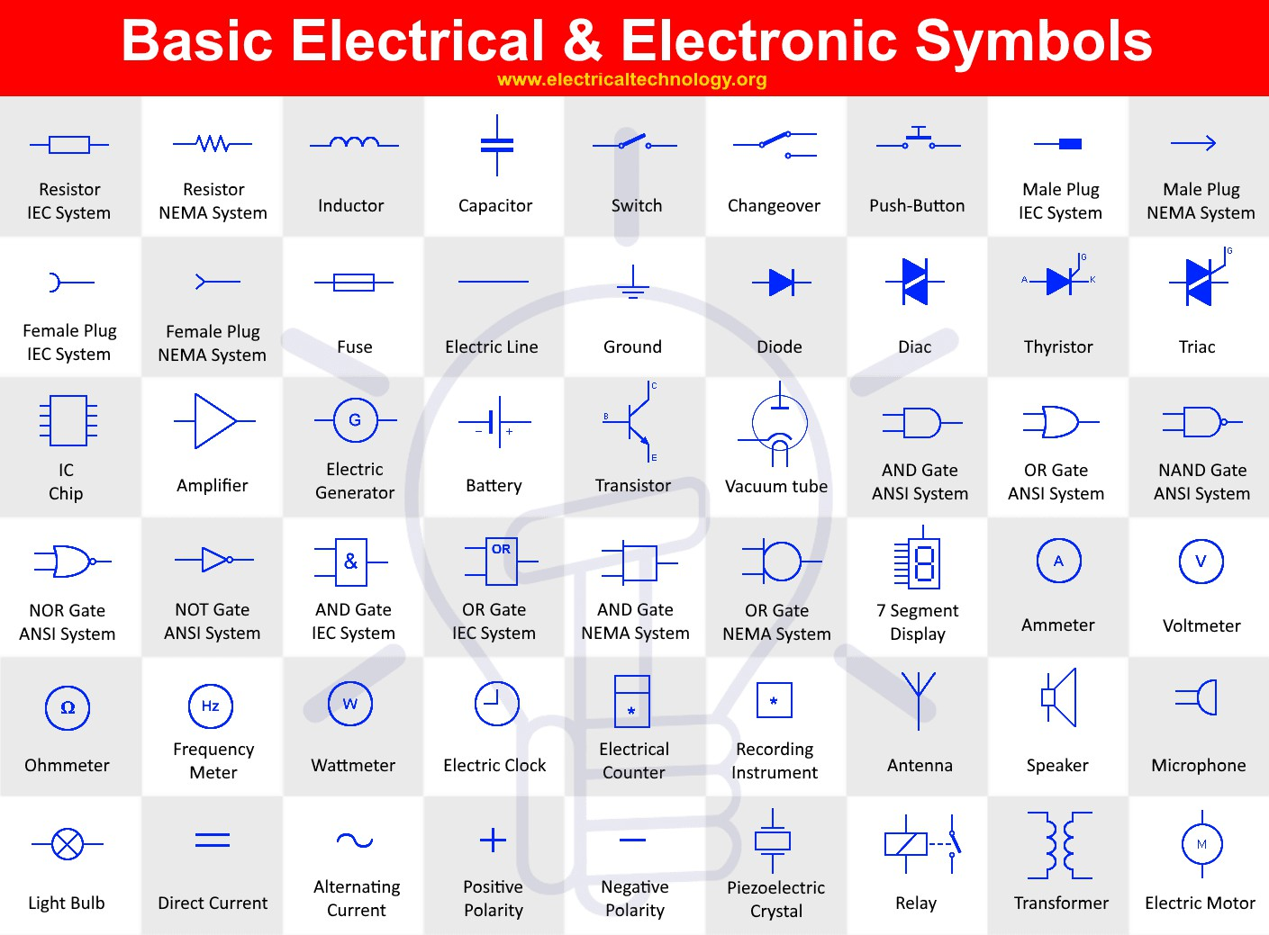
The schematic symbols chart above shows standard representations for common electronic components. These universally recognized symbols are used in circuit diagrams and electronic schematics.
Key Symbol Categories:

Passive Components: Resistors are shown as zigzag lines or rectangles, capacitors as parallel lines, and inductors as coiled lines

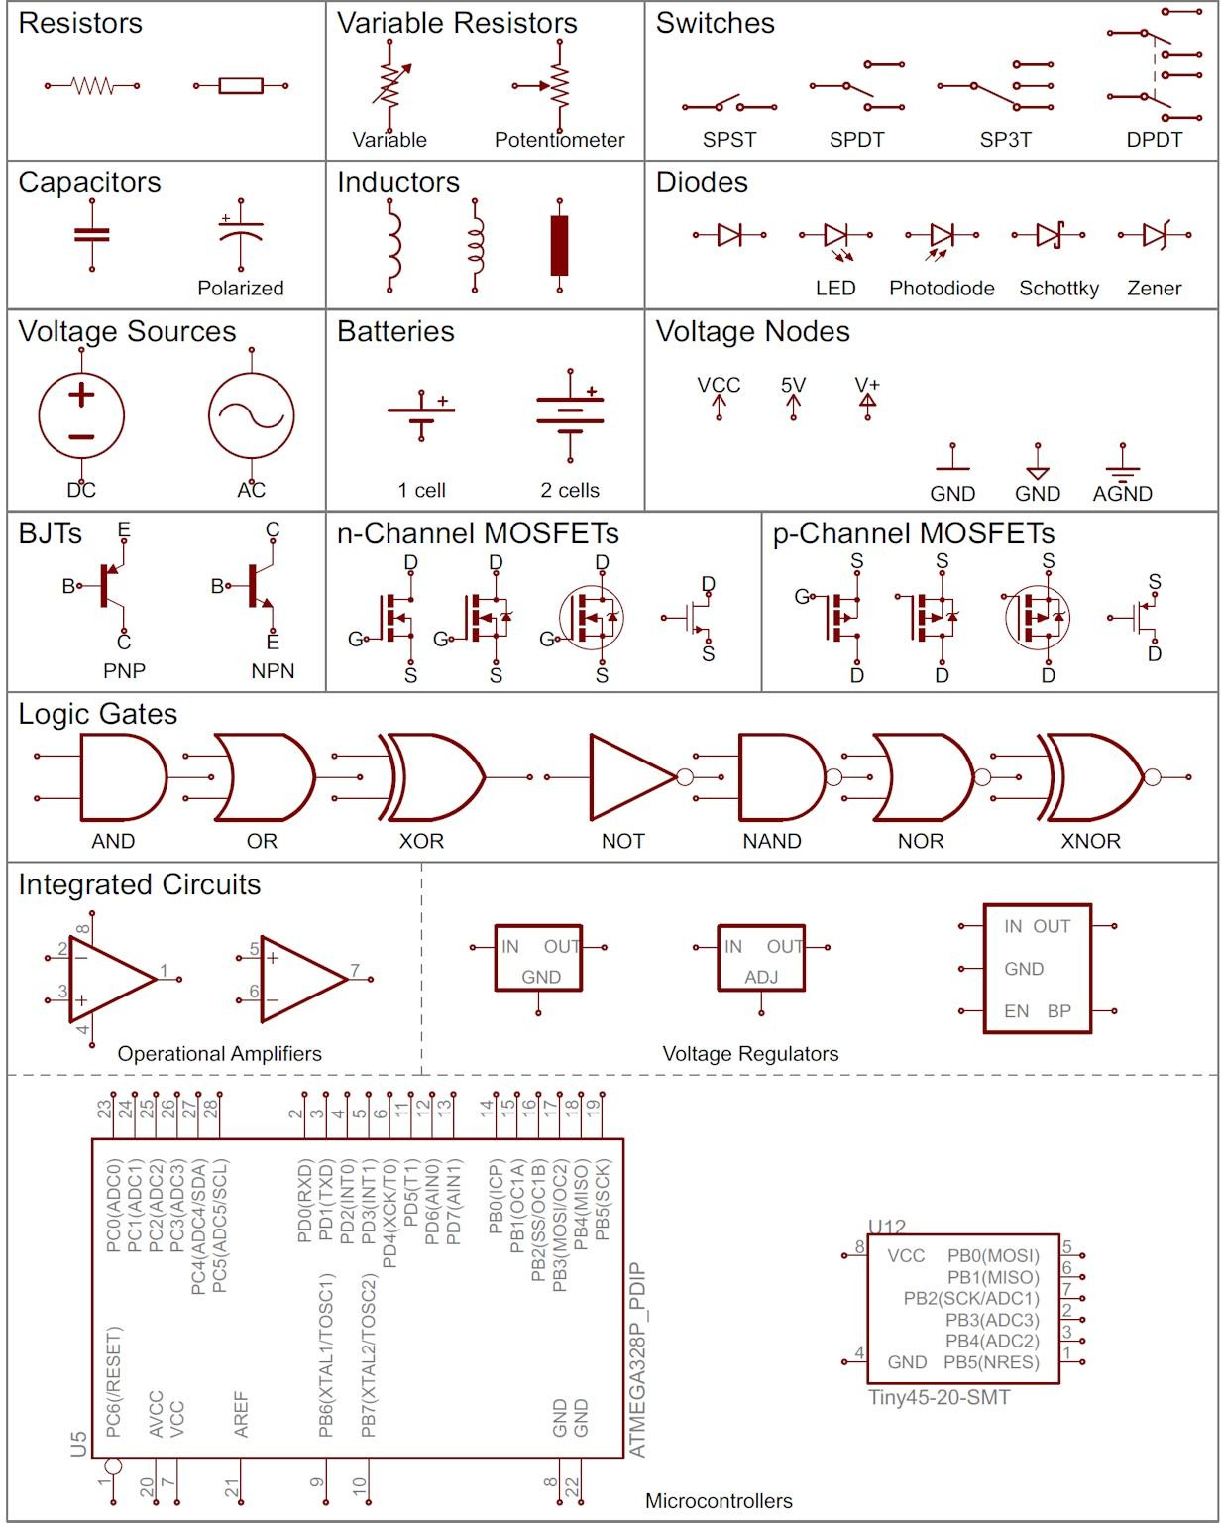
Compact table of basic electronic schematic symbols including resistors, capacitors, switches, diodes, transistors, logic gates, and microcontrollers.

Report Organization Structure
This investigation systematically covers 50 fundamental electronic components organized by functionality:[2]
- Passive Components (1-3): Resistors, Capacitors, Inductors - foundation elements providing resistance, capacitance, and inductance
- Semiconductor Devices (4-17): Diodes, Transistors, Photodevices, Special-purpose diodes - active components for switching, amplification, and signal processing
- Integrated Circuits (7, 21, 44-45): Complex ICs including regulators, op-amps, and programmable logic devices
- Electromechanical Components (8-10, 20, 25-29): Transformers, relays, switches, and transducers bridging electrical and mechanical domains
- Control & Adjustment Devices (11, 36-38): Potentiometers, buttons, and trimmers for user interface and calibration
- Power Sources (30-31, 43): Batteries, solar cells, and power supplies providing electrical energy

- Circuit Building Tools (32-34, 40): Breadboards, connectors, and PCBs for physical circuit construction
- Digital Components (41, 50): Logic gates and displays for digital signal processing and visualization

- Combined Circuit Configurations (46-49): RC circuits, LC circuits, voltage dividers, and thyristors for specific applications

Conclusion
This comprehensive investigation provides detailed knowledge of 50 fundamental electronic components essential for electronic system design. Each component has been analyzed for its explanation, working principle, practical applications, schematic representation, and internal structure. Understanding these components is crucial for circuit analysis, design, and practical implementation of electronic projects. This report fulfills the Active Learning Method requirements for the Electronic System Design course, demonstrating thorough research and documentation of electronic components used across various applications in modern electronics.

